***What are Social Work Units?***

Reclaiming Social Work in Aberdeen

2 : Social Work Units

Reclaiming Social Work in Aberdeen

2 : Social Work Units

Reclaiming Social Work in Aberdeen

2 : Social Work Units

Reclaiming Social Work in Aberdeen

2 : Social Work Units

Social Work Units will be multidisciplinary groups of five practitioners who co-work a caseload. Allocation of cases to Units rather than individuals ensures that practitioners are well supported in their analysis of risk and implementation of interventions.

***What are Social Work Units?***

Social Work Units will be multidisciplinary groups of five practitioners who co-work a caseload. Allocation of cases to Units rather than individuals ensures that practitioners are well supported in their analysis of risk and implementation of interventions.

Although the Consultant Social Worker is ultimately responsible for each case, all Unit members collaborate on casework, offering a variety of different skills and perspectives to their work with children and families.

The **Consultant Social Worker (CSW)** will lead and manage the Unit and support staff to practice consistently high quality social work. They will be responsible for all cases the Unit holds, as well as managing the day-to-day work of the Unit. They will work directly with young people, deliver systemic interventions and lead the Unit whilst embedding a transparent, collaborative and reflective culture.

***Who is in a Social Work Unit?***

The **Social Worker\*** undertakes social work activity with families and is supervised by the Consultant Social Worker.

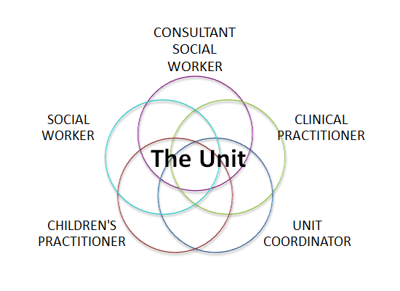

The **Clinical Practitioner** undertakes clinical assessments of families and works with the members of the Unit to consider how to bring systemic approaches into all the work they do.

The **Unit Coordinator** co-ordinates the activities of the Social Work Unit by managing diaries and meetings. They are often the first point of contact with families, and are invaluable in freeing up practitioner time.

The **Children’s Practitioner** also works directly with families and is supervised by the Consultant Social Worker.

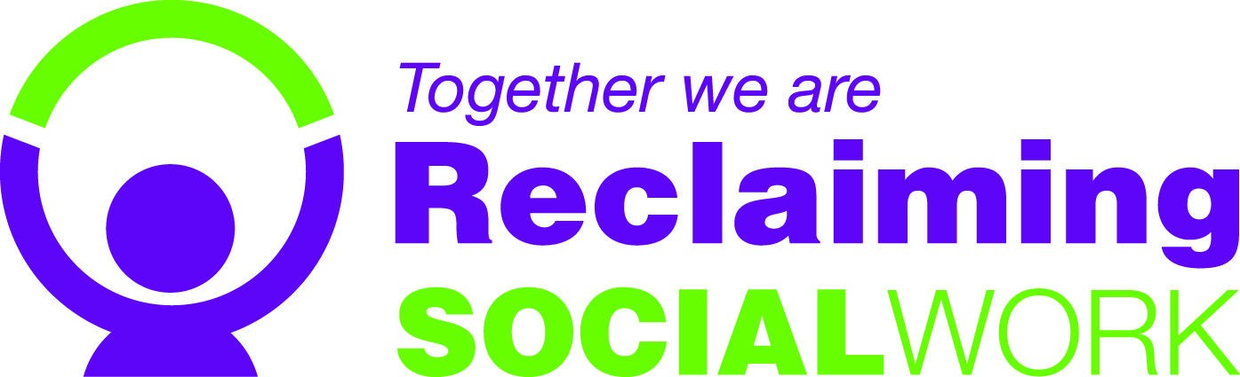

* : In Permanence Units and those at AMH there will be two Social Workers, rather than a Social Worker and a Children’s Practitioner.

***Social Work Unit meetings***

Unit meetings will be held weekly. They will provide the opportunity for a high-quality, case based, reflective discussion which is essential to good risk assessment and implementing evidence based intervention with children and families. All Unit members will be involved and every case open to the Unit will receive attention. The discussion will be balanced between reflective, analytical and hypothetical thinking with action focused, goal orientated case planning.

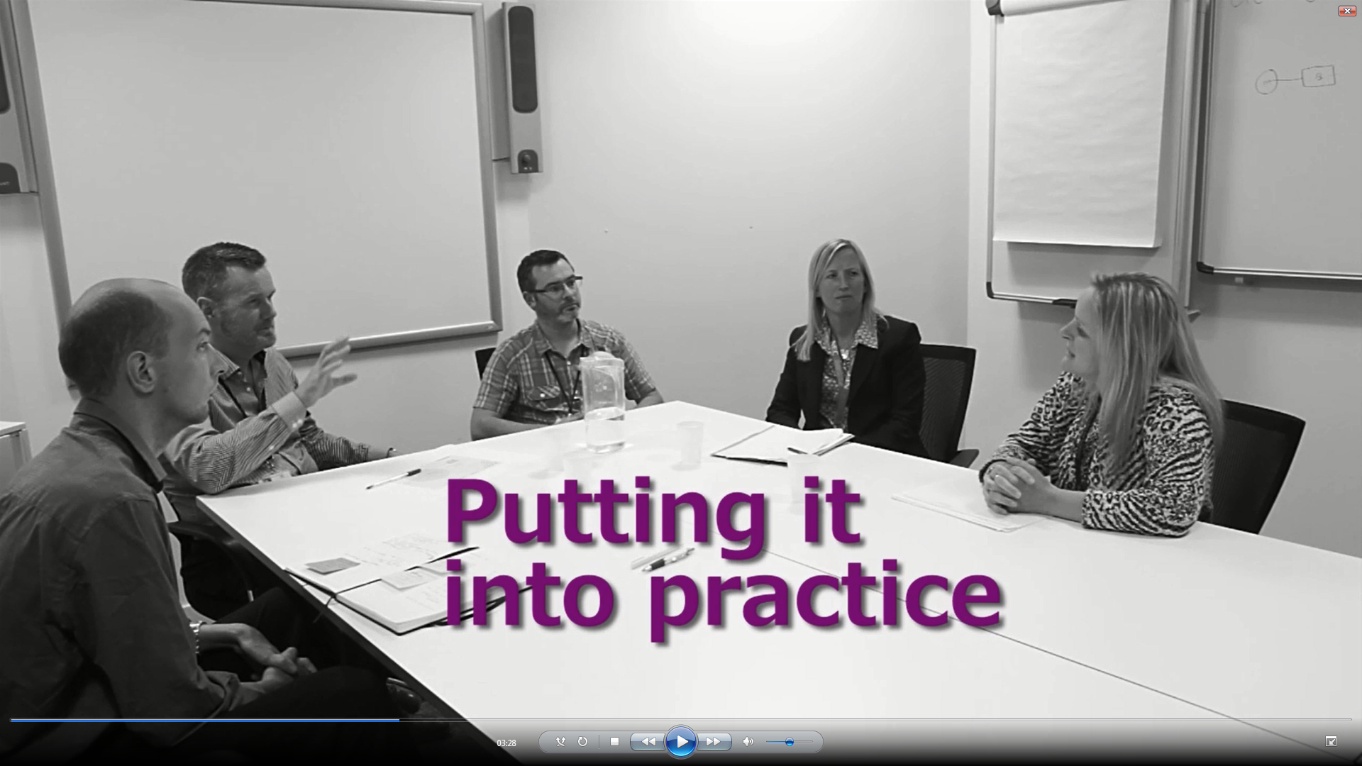

***How many Social Work Units will there be in Aberdeen?***

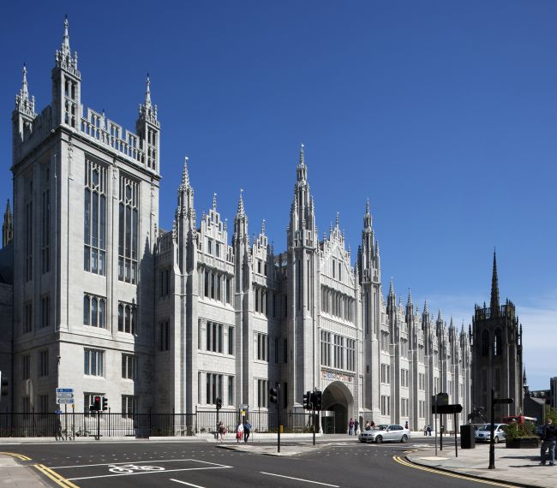There will be 34 Units throughout the city working in a number of locations including the City Council’s main offices in Marischal College. We are confident that this will give us sufficient cover based on a number of caseload audit and weighting exercises that we have undertaken. Of these 34, two Units will be based at Aberdeen Maternity Hospital, whilst six Units will work primarily with short term work. The remaining 26 Units will work with families on a long term basis following an assessment and plan either in permanence and care or children in need. There will also be at least one Unit specialising in Children with Disabilities.

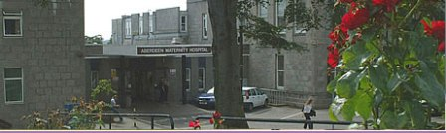

In addition to the 34 Units we will retain a ‘front door’ service comprising a Reception Team and the Joint Child Protection Unit, along with the two Units based at the Maternity Hospital.

***Will there be specialist Social Work Units in Aberdeen?***

There will be some specialist Units. This will include children with disabilities and permanence work, which is currently devolved to specialist teams. There will also be a children with disabilities team and a youth team.

Reclaiming Social Work in Aberdeen

|  |  |  |
| --- | --- | --- |
|  | *For more information about Reclaiming Social Work in Aberdeen or about jobs in Children’s Social Work in the city please contact us by e-mail:* [*together@aberdeencity.gov.uk*](mailto:together@aberdeencity.gov.uk) *or by phone on 01224 522533 or at our website http://www.aberdeencity.gov.uk/jobs_careers/jobs_and_careers.asp* |  |